The Senate Bill Lowers Non-Group Premiums: Updated for New CBO Estimates
Jonathan Gruber, MIT
November 27, 2009

The Senate Bill issued this week provides premium assistance and market reforms which will make health insurance much more affordable for individuals facing purchase in the non-group market. The premiums that individuals will face in the new exchanges established by this legislation are, according to the non-partisan Congressional Budget Office, considerably lower than what they would face in the non-group insurance market, due to the market reforms put in place by the Senate Bill, the mandate on individuals to participate regardless of health, and the market economies of new exchanges. This memo illustrates this point by relying solely on analysis available from CBO, as well as the details of the premium assistance available through premium credits in the Senate plan.

Background

In a letter to Senator Reid on November 20, the Congressional Budget Office (the official government scoring agency) reported that they estimated the cost of an individual low-cost plan in the exchange to be $5200 in 2016. This is a plan with an “actuarial value” (roughly, the share of expenses for a given population covered by insurance) of 70%. In their most recent communication with Congress, CBO also projected that, absent reform, the cost of an individual policy in the non-group market would be $5500 for a plan with an actuarial value of 60%. This implies that the same plan that cost $5500 without reform would cost $4460 with reform, or almost 20% less.

The CBO has not reported many of the details of their analysis, such as the age distribution of individuals in the non-group market or in the exchange. So these data do not provide a strictly apples to apples comparison of premiums for the same individual in the exchange and in the no-reform non-group market. And their conclusion may change as legislation moves forward. But the key point is that, as of now, the most authoritative objective voice in this debate suggests that reform will significantly reduce, not increase, non-group premiums.

This conclusion is consistent with evidence from the state of Massachusetts. In their December 2007 report, AHIP reported that the average single premium at the end of 2006 for a non-group product in the U.S. was $2613. In their October 2009 report, AHIP found that the average single premium in mid-2009 was $2985, or a 14% increase. That same report presents results for the non-group markets in a set of states. One of those states is Massachusetts, which passed a health care reform similar to the one contemplated at the federal level in mid-2006. The major aspects of this reform took place in 2007, notably the introduction of large subsidies for low income populations, a merged non-group and small group insurance market, and a mandate on individuals to purchase health insurance. And the results have been an enormous reduction in the cost of non-group insurance in the state: the average individual premium in the state fell from $8537 at the end of 2006 to $5143 in mid-2009, a 40% reduction while the rest of the nation was seeing a 14% increase.

Example

As an example of the savings individuals may see under the Senate Bill, I consider the case of the typical single person buying non-group insurance compared to the typical single person in the exchange, as well as comparing the typical four person family in both the non-group market and the exchange. For the non-group market, I assume that the typical premium for a family of four is 2.7 times the single premium, as with group insurance. The impact is for 2016, when reforms are fully phased in, although income is expressed in $2009 for ease of interpretation. To deflate costs from 2016 to 2009, I use the CPI (the rate of growth of the poverty line) for those who are paying a percentage of income, and I use the rate of premium growth for those who are paying the full premium. The analysis compares what they would pay if they are currently insured in the non-group market versus what they will pay in the exchange.

Figures 1 and 2 show the results of this analysis. I find that the savings are large for both singles and families, and that they are particularly large for the lowest income families that qualify for premium credits under the Senate Bill but would be left to face the full high non-group premium without legislation. In particular, I find that the single individual would save over $2500 at low incomes (175% of poverty), and would save $200 even at higher incomes (425% of poverty or higher). For families, the savings are much larger, ranging from nearly $7500 for low income families (at 175% of poverty) to $500 for higher incomes (425% of poverty or higher).

It is worth noting that these savings are all in addition to the more generous benefits that these groups will receive through the exchange compared to the non-group market. The CBO reports that their estimated premium in the non-group market corresponds to an actuarial value of 60%. The actuarial values used in these estimates are as high as 80% (for those at 175% of poverty) and are at their lowest 70% (for those above 350% of poverty). So not only does the Senate proposal lower premiums, it does so while also improving coverage.

Conclusion

Analysis of the non-partisan information from the CBO suggests that for those facing purchase in the non-group market, the House bill will deliver savings ranging from $200 for singles to $500 for families in today’s dollars – even without subsidies. The savings are much larger for lower income populations that receive premium credits. This is in addition to the higher quality benefits that those in the exchange will receive, with actuarial values for low income populations well above what is typical in the non-group market today. It is also in addition to all the other benefits that this legislation will deliver to those consumers – in particular the guarantee, unavailable in most states, that prices would not be raised or the policy revoked if they became ill.
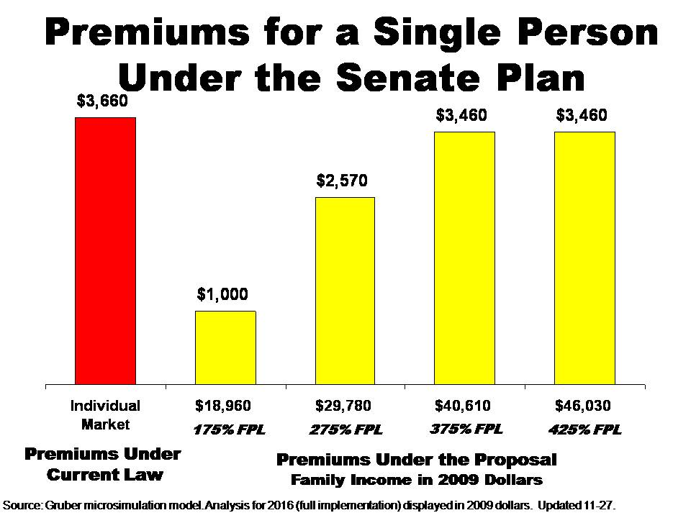
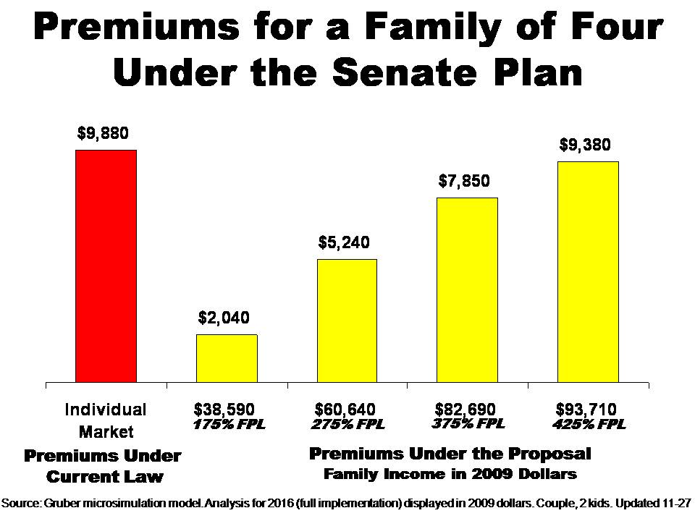

Note that my methodology here differs slightly from a comparable analysis for the Senate Finance bill, where I used one common deflator for all figures and undertook the comparison for the first year of the legislation, rather than the third year. But the savings estimates are similar to what I would get under that alternative method.

